Job Description

Policy & Public Affairs Officer (17.5 hours or 2.5 days per week)

Department: Policy and Strategy

Reports to: Head of Policy and Public Affairs.

Key internal relationships: Policy and Public Affairs team
Clinical Advice & Guidance team
Director of Policy & Strategy
Marketing and Communications teams
Knowledge and Research directorate
Education directorate
Various College review groups

.

Key external relationships: College members
General Optical Council (GOC)
Optometric bodies in the devolved nations
UK optical bodies
Professional bodies in the eye health and care sector
UK national health services
Patients and the public

Purpose of the role
To support the development of policy and public affairs work through gathering evidence, analysis and synthesis of information, developing effective relationships and production of effective communications. To coordinate the College’s new Policy Advisory Panel. To support College activities to build effective policies, campaigns and influencing programmes around key issues for members and patients.

Main responsibilities

Policy & Public Affairs support and intelligence
- Delivering, along with others in the team, agreed policy and public affairs activities including gathering evidence, synthesis of information, and production of effective communications. This includes keeping logs of relevant activity up-to-date.

- Proactively identifying relevant consultations and coordinating the College’s responses to them.
- Monitoring and coordinating College responses to policy queries from members and stakeholders.
- Acting as the point of contact for the secretariat of the Clinical Council for Eye Health Commissioning (CCEHC) to support the CCEHC Chair and Vice-Chair, prepare agenda and papers for the CCEHC meetings, ensure the governance arrangements are followed, support working groups and communicate with members.
- Support the Policy & Public Affairs team to keep abreast of developments by collating sources of evidence, and tracking and sharing updates from external organisations.
- Representing the College’s policy and public affairs team at internal and external meetings.

Communicating policy developments
- Supporting the development of external policy resources, including briefings and presentations for members and stakeholders.
- Maintaining the College’s resources on key facts and figures and ensuring they are kept up-to-date and accurately referenced.
- Maintaining the College Policy log.
- Keeping the list of College’s policy key messages up-to-date and ensuring it is used to inform relevant communications.
- Communicating policy and public affairs developments with colleagues across the College, and ensuring College policy webpages are accurate and up-to-date.

College external representatives
- Ensuring the list of College external representatives is kept up-to-date.
- Supporting the recruitment of new College external representatives as required and ensuring the governance arrangements are followed.
- Ensuring regular and consistent communication with College representatives to provide clinical and policy briefings, and to receive updates about the activities and decisions of the committees they sit on.
- Liaising with experts across the College to support representatives in effectively contributing to the work of the committees they sit on.
- Developing and maintaining a log of College external representatives’ activities.

Influencing and collaboration
- Supporting the Policy & Public Affairs team in the development, delivery and review of the Public Affairs strategy.
- Coordinating the College Policy Advisory Panel by ensuring that the membership numbers are maintained, new members recruited as required, members are updated on key College activities and the Panel meets at agreed intervals. Ensure the governance arrangements are followed, for example, when individuals complete their terms of membership and when recruiting new members.
- Using our parliamentary monitoring service and other sources to identify key developments in health and public affairs and regularly updating colleagues.
- Working with colleagues across the College in planning, informing and achieving influencing activities.
- Building relationships with external stakeholders, decision-makers and governments across the UK.

Other College work
- Uphold the values of the College and maintain its integrity as impartial and authoritative.
- Contribute towards the delivery of the department’s objectives.
- Carry out from time to time and as directed, any other duties as required in addition to the above that will be both reasonable and within your capabilities.
- Ensure that at all times you take care of your health and safety and that of others by complying with health and safety obligations, particularly by reporting promptly any defects, risks or potential hazards.
- Act in accordance with the College values.

Team structure

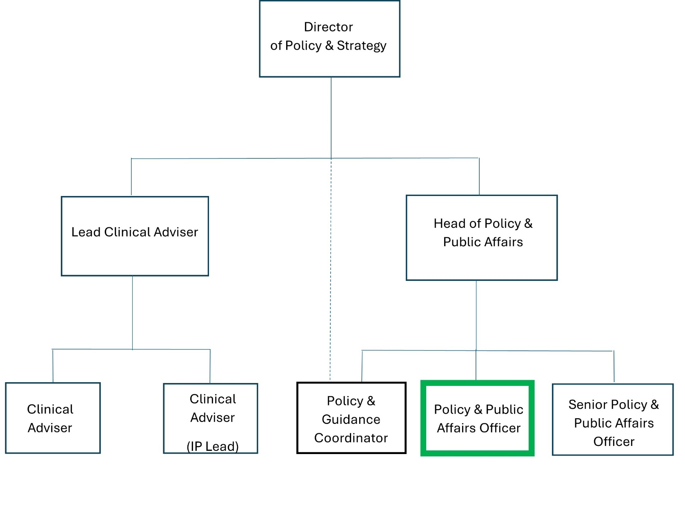

Person Specification

Experience

Essential:
- Developing evidence bases
- Developing clear, evidence-based policy positions
- Drafting responses to consultations
- Supporting the planning and implementation of effective influencing activities
- Engaging stakeholders
- Writing clear and effective reports and other communication materials
- Managing detailed processes which require accuracy and attention to detail
- Working with multiple projects and teams
- Working to tight deadlines

Desirable:
- Working in a professional body, membership organisation or research organisation
- Working in a health-related organisation
- Working closely with health professionals and the public

Education / Qualifications

Essential: Qualifications in Maths and English

Desirable: Educated to degree level or equivalent experience

Skills and knowledge

Essential:
- Ability to analyse and synthesise information from a wide range of sources
- Good project management skills
- Good working knowledge of public policy development and the governments of the four UK nations
- Ability to keep track of detailed and complex processes
- Clear and accurate written and verbal communication skills
- Ability to write effective, evidence-based reports and other documents
- Can tailor information for different audiences
- Ability to work very flexibly and be able to respond to changes in the external environment at short notice
- Excellent attention to detail and accuracy
- Good knowledge of MS Office: Word, Outlook, Excel and Power Point

Desirable:
- Good working knowledge of public health policy and the health systems of the four UK nations
- Knowledge of the current issues facing optometry and/or primary health care

Personal Attributes
- Proactive and self-motivated
- Able to work well as part of a team
- Able to learn quickly and pick up new terminology
- Able to plan ahead, anticipate problems and offer solutions
- Well organised
- Flexible and responsive
- Ability to use initiative
- Willing to undertake routine tasks
- Politically sensitive
- Diplomatic and able to collaborate with colleagues, members and external stakeholders
- Able to manage own time and workload
- Able to deliver and achieve deadlines

Additional Information
Typical daily working hours at the College are 7 hours, excluding lunch. We operate a flexible working window from 8 am to 6 pm where you can vary your start and end time and have other flexible working opportunities available. This post is for 17.5 hours or 2.5 days a week.

This post can be based at our London office (42 Craven Street, London, WC2N 5NG), but we are open to hybrid working (a mixture of home and office working) and will consider the postholder being fully remote. Both hybrid and remote working will require access to a broadband connection. The postholder will be able to agree their working pattern on appointment, but you will be expected to work on Tuesday afternoons to cover departmental needs, including attending department meetings in person at the office once a month. On some other occasions, you may be asked to work in the office to meet business needs.

The post holder may on occasion be required to work in the evening approx. 8 times a year to attend virtual Policy Advisory Panel meetings and review group meetings, and applicants should therefore have some flexibility with regard to working hours. The post may also include some UK travel and occasional nights away from home.

Equal Opportunities and Inclusion
The College is committed to providing equal opportunities in employment and to avoiding unlawful discrimination. We value the differences that a diverse workforce brings to the organisation.

Our values

